Assignment 2:

Flowchart Creation - Design a flowchart that outlines the logic for a user login process. It should include conditional paths for successful and unsuccessful login attempts, and a loop that allows a user three attempts before locking the account.

Solution:

Here's a flowchart outlining the logic for a user login process with conditional paths for successful and unsuccessful login attempts, and a loop that allows a user three attempts before locking the account:

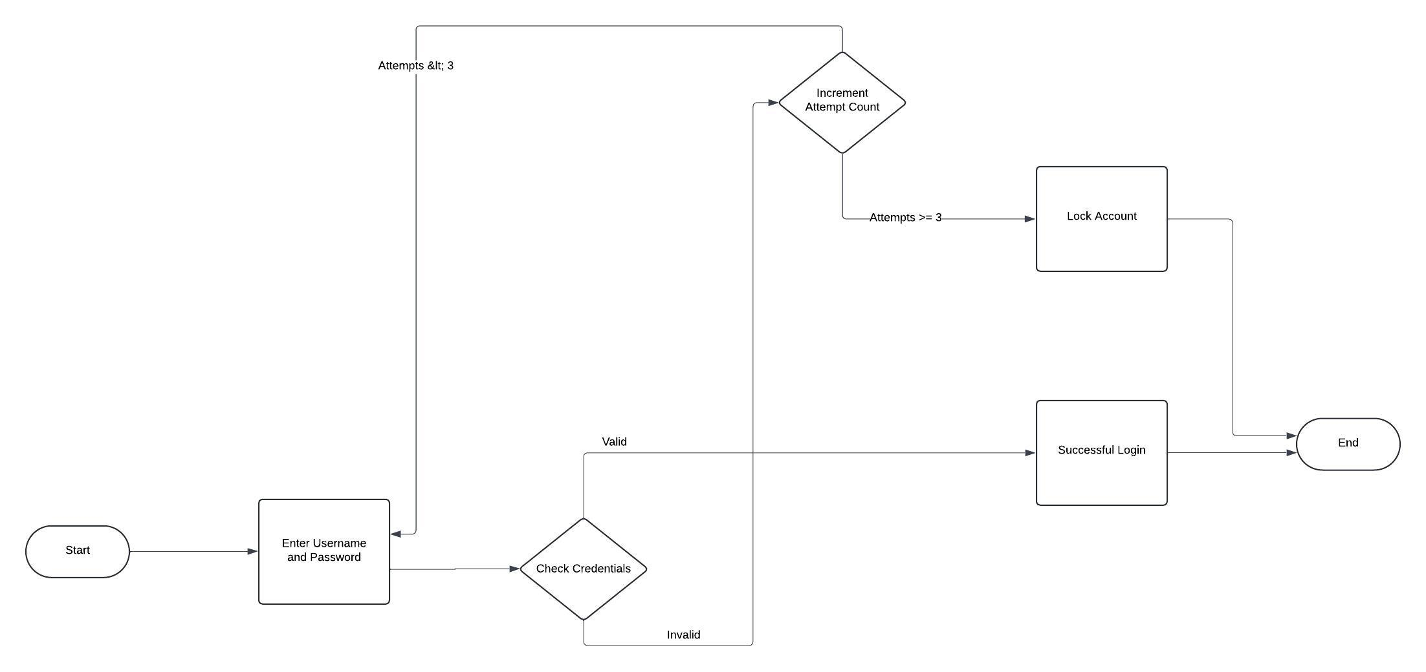

Explanation:

1. The process starts with the initialization of the number of attempts made by the user.
2. The user enters their username and password.
3. The system validates the entered username and password.
4. If the login is successful, the system displays "Login Successful" and ends.
5. If the login fails:
   * The system increments the number of attempts made.
   * Checks if the number of attempts is less than 3.
     + If yes, the system displays "Invalid Login. Please try again." and loops back to allow the user to enter the username and password again.
     + If no, the system displays "Account Locked" and ends.

Top of Form